Ruud Egging-Bratseth, 10 december 2024

This the MGET implementation in GAMS.

Currently there are two scenarios implemented: Iberian Peninsula “Spanish Case”, a moderate and an ambitious decaronbization / hydrogen uptake scenario.

## Installing and running the model.

Unpack the Zip file MGET_20241210.zip

Download and install GAMS <https://www.gams.com/download/>

Open MGET.gsp (see below)

From GAMS, open MGET.gms

To choose the scenario, determine the value of global parameter scen:

$SETGLOBAL *scen 2 /* Decarb & H2 scenario 0 Moderate, 2 Ambitious */*

These are the files in the Zip folder:

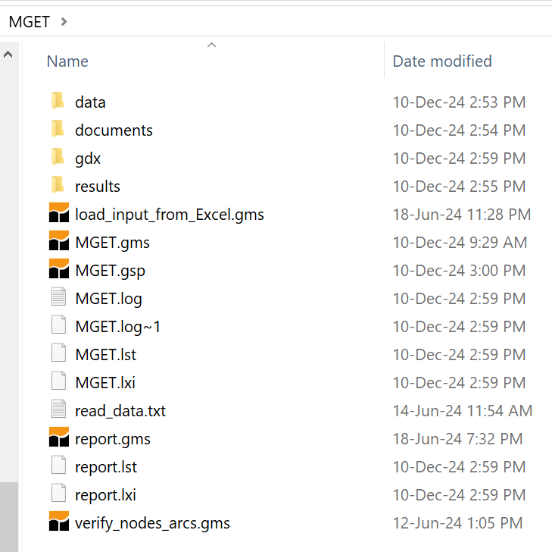

* .gsp is the GAMS project file
* .gms files are GAMS files
* .log are log files
* .log~N, with N some integer value, are old log files.
* .lst is gams listing file, with information about the GAMS model flow and feedback on a solve.
* .lxi is a GAMS auxiliary file

## Model files

| **File name** | **Comment** | **Comment** |
| --- | --- | --- |
| MGET.gms | Main file | Set moderate 0 or ambitious 2 scenario via  $SETGLOBAL *scen 2*  Set max computation time  **option** **reslim**=7200;  Currenty using cplex  **mip**=cplex |
| *load_input_from_Excel.gms* | Load all input data |  |
| *data/%hor%.gms* | Load time horizon | 2040.gms |
| *data/scen_*%string%*_sup.gms*  *data/scen_*%string%*_dmd.gms* | Scenario files for specific “string” combinations | scen_Spain_2040_4_0_sup.gms  scen_Spain_2040_4_2_sup.gms  scen_Spain_2040_4_0_dmd.gms  scen_Spain_2040_4_2_dmd.gms |
| Verify_nodes_arcs.gms | Test file | Verifies data values for arcs |
| *report.gms* | Reporting file |  |

## Input file

|  |  |  |
| --- | --- | --- |
| Spain.xlsx | File with input data for the Spanish case | Except for scenarios; these are hard-coded in the include files  *scen_*%string%*_sup.*  *scen_*%string%*_dmd.* |

## Scenarios

### Spanish case – scenarios moderate 0 & ambitious 2

$SETGLOBAL *data Spain /* TEST,MGET,Spain,Blending */*

$SETGLOBAL *hor 2040 /* Last year in planning horizon: /*

$SETGLOBAL *oper 4 /* Operational hours */*

$SETGLOBAL *scen 2 /* Decarb & H2 scenario 0 Moderate, 2 Ambitious */*

## Solution times

The ambitious scenario uses the entire preset solution time of 2 hours / 72000 seconds – the remaining gap is 0.04% , larger than the solution tolerance